*CPEG 210L-3 Project*

*Scrolling Marquee with Name*

*Name:-*

*ID’s:-*

*Date of Submission:-*

*Objective*

**Rotating Marquee of Alphabets with your own Name**

*Introduction*

In order to Design Such a Circuit we need to have Knowledge of Seven Segment Displays and Decoders.

After Assigning Each letter of the Alphabet a binary Code we need to design K Maps of every Input in the 7 segment Display .

We will also need Shift Registers Which shift the output onto the next Display

* 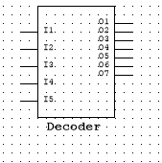Decoder

We use a 5 input 7 output decoder in which 5 inputs given are binary inputs of Alphabet and 7 Outputs Connected to the 7 segment Display

* 7 Segment Display

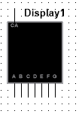The 7 Segment Display is used to display the output Corresponding to the Given input

* 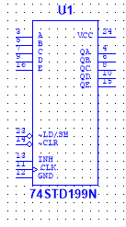Shift Register

Shift Registers here are used to Shift the Output of Letter onto the next Display

* 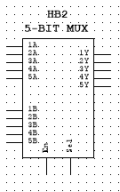Multiplexer

5 Bit Multiplexer is Designed which takes 5 inputs and switches the input lines

* 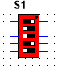DipSwitches

DipSwitches are used to Give the Desired Input for the Required Letter in the Circuit

*Methodology*

First we Design a Truth Table in which input Corresponding to every alphabet are assigned and their 7 segments outputs are also given

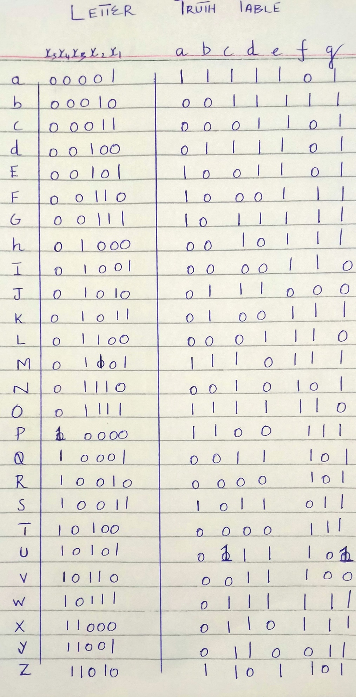

Then K Maps are Drawn respective to each input of the 7 Segment Display and are Enclosed in a Hierarchal Block which makes a 5 input to 7 output Decoder

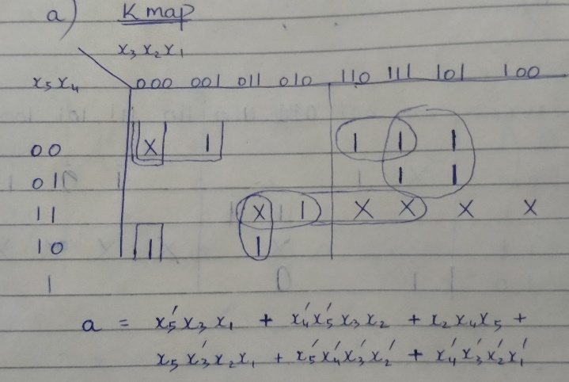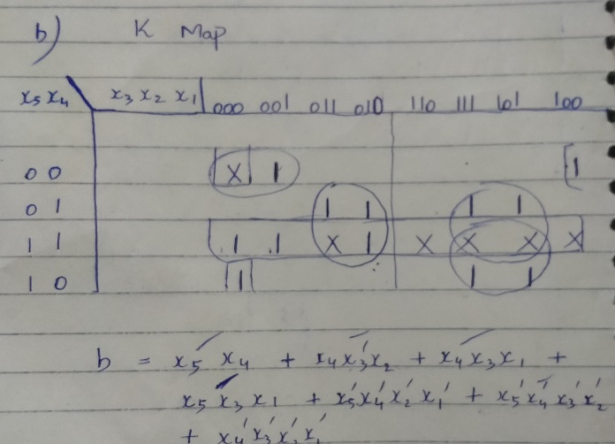a Kmap b Kmap

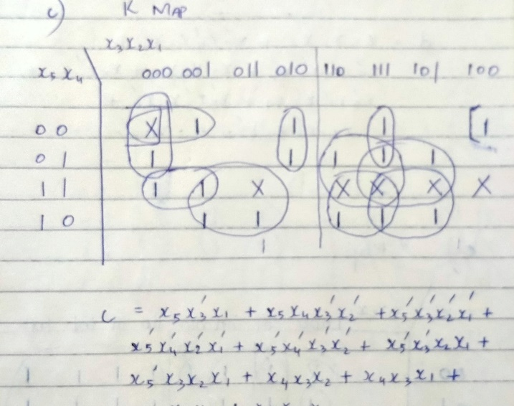c Kmap d Kmap

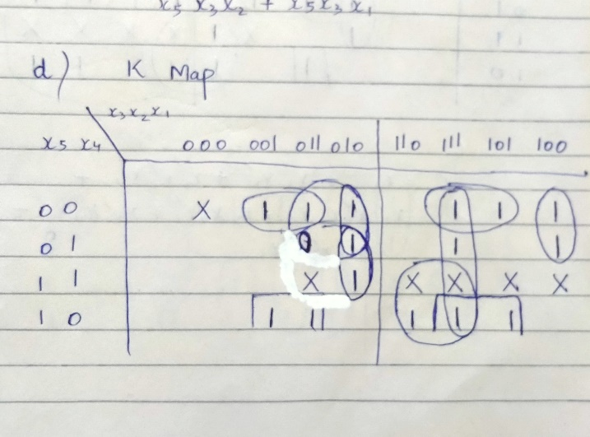

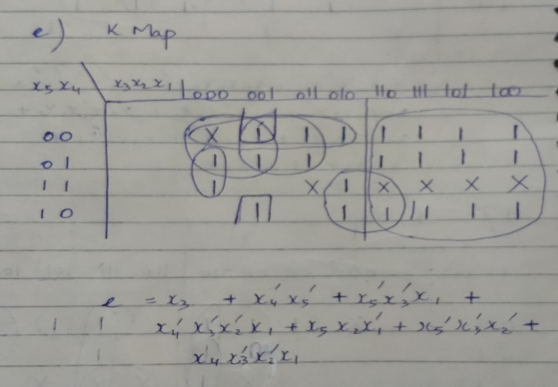E Kmap F Kmap

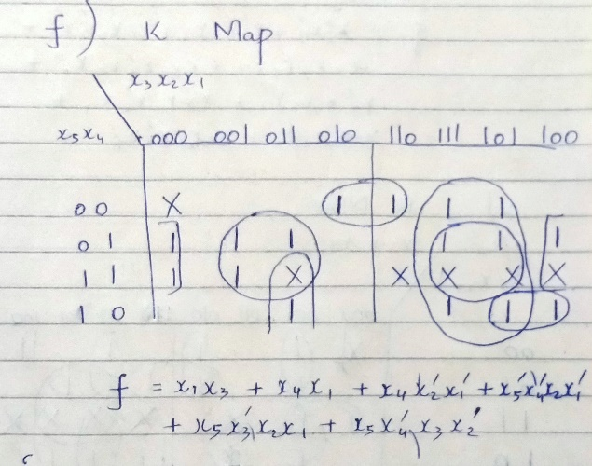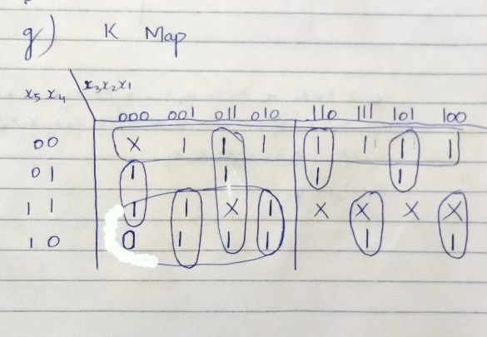

G Kmap

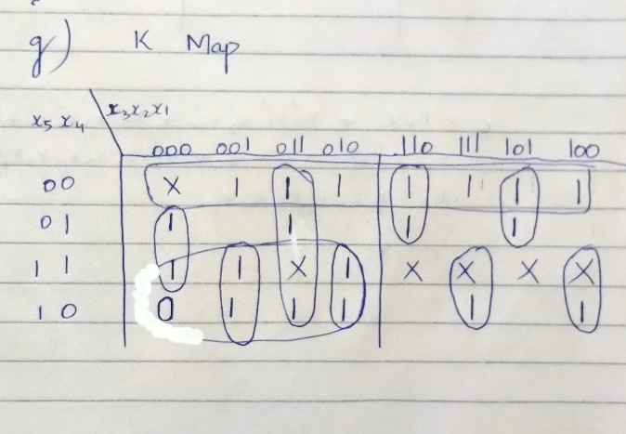

When the input is given through Switch of the required Alphabet the input goes into the register which shifts the input onto the Decoder giving us the required Alphabet .

Decoder Designed From Kmaps Is given Below

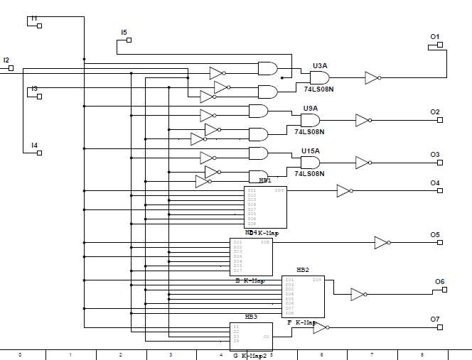

The Select input Key then Selects the Next input and the Next input is given to the Shift register Which Shifts the previous input onto the next display and next input is Displayed by the 7 segment as it passes through the decoder

A general Representation of a part of Circuit is Given

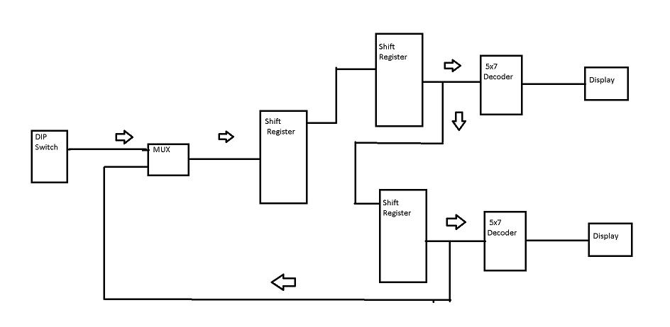

*Results*

When the Select Switch is Turned the First input is loaded onto the registers which forward the input onto the decoders and desired letter is displayed .

Then after when select input is turned the next input is loaded by the multiplexers onto the shift registers and decoder which shifts the previous input forward and new input is appears on the Display . The clear Input Clears All of the Input in the Registers. This process continues until the Simlation is Stopped.

The OutPut is Then Displayed One By One On each Segment

The Proper Circuit is Given Below

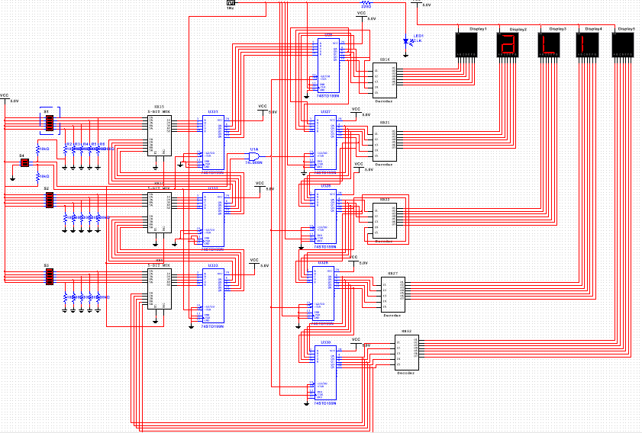*Conclusion*

Project is Successful and Working on the desired inputs.